MFA Charter Oak Students/Faculty
Multi-factor authentication has been enabled for Charter Oak State College students and faculty. This is an added layer of security to further protect your information. This document will walk you through how to set up multi-factor authentication on your Charter Oak Office 365 account.
- Go to the login screen for Office 365 by clicking on the following link https://login.microsoftonline.com/ This is where you will be able to access Microsoft Office applications such as Word, Excel, etc., along with your Charter Oak student/faculty email account.
- Enter your Charter Oak email address then click Next.
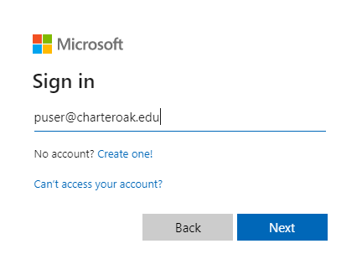
- Enter your Charter Oak account password then click Sign In. NOTE: this is the same password you use to log into your My Charter Oak and Blackboard accounts.
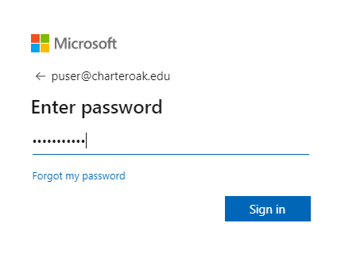

- On more information required click Next.
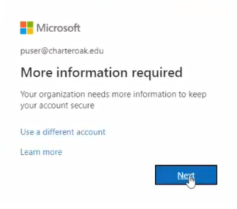
- Enter in a phone or cell number you have access to. Select either the Call me or Text me a code option, then click Next. NOTE: Make sure this is a number you have ready access to as you will need it for subsequent log ins.
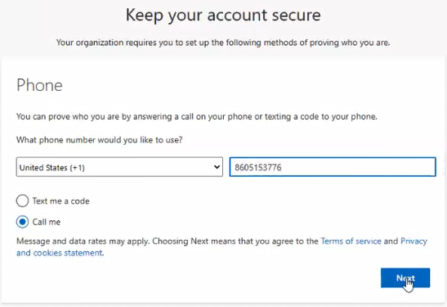
- If you previously chose Text me a code, you will receive a 6-digit code via text message. Enter in the 6-digit code and click next. If you previously chose Call me, you will receive an automated call. Listen to the automated call then press the # key. You have now successfully set up your phone as your multi-factor authentication method.

- You will be brought back to the login process as normal. On more information required click Next.
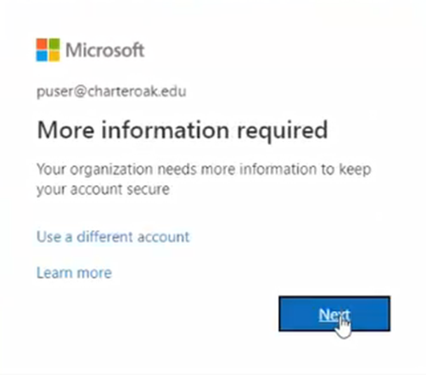
- You will now be prompted for how you would like to verify your identity. This is where all your multi-factor authentication methods you have set up will be listed. Choose the method you would like to use and complete it - this will be identical to the process outlined in step 6. This is how subsequent log ins will behave.
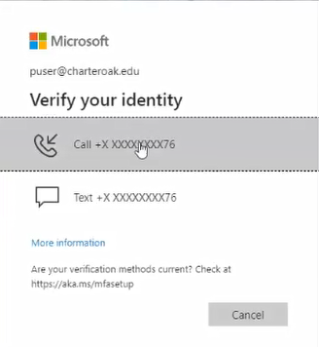
- You have now successfully setup multi-factor authentication for your Office 365 account and used said authentication method to sign in. You can now optionally setup other methods of authenticating such as Microsoft Authenticator app, a personal email address, or another phone number. To do this go the Security Info section of your Office 365 account settings.

