To set up Microsoft Authenticator App (this is an optional verification method)
*Note – users will need to have already logged into their account to configure the Authenticator app.
- Sign into your work or school account and then go to your My Account portal.
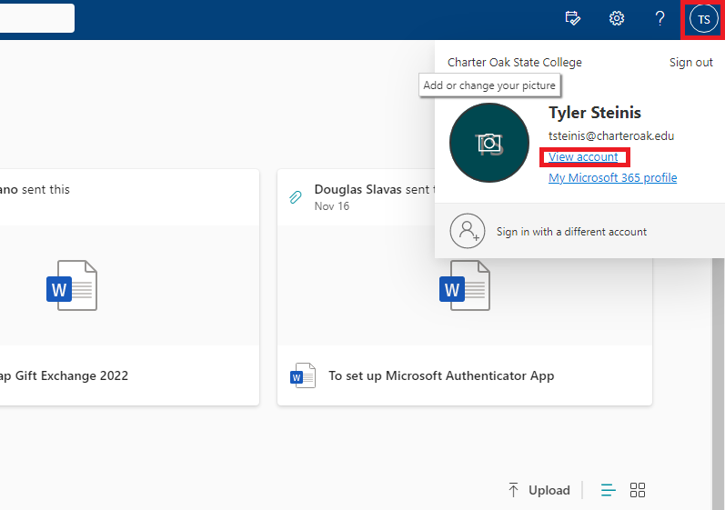
- Click on the circle containing your initials located in the top right-hand section of your screen. Then In the popup menu click on View account.
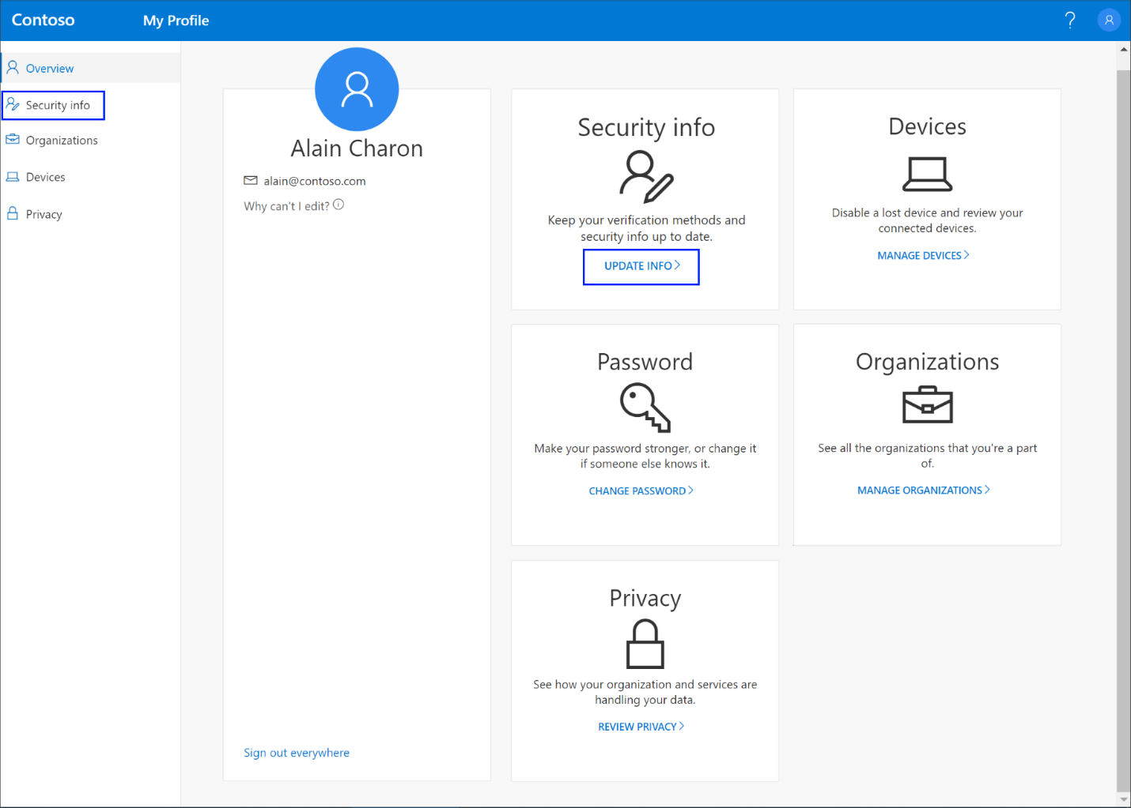
- Select Security info in the left menu or by using the link in the Security info pane. If you have already registered, you'll be prompted for two-factor verification. Then, select Add method in the Security info pane.
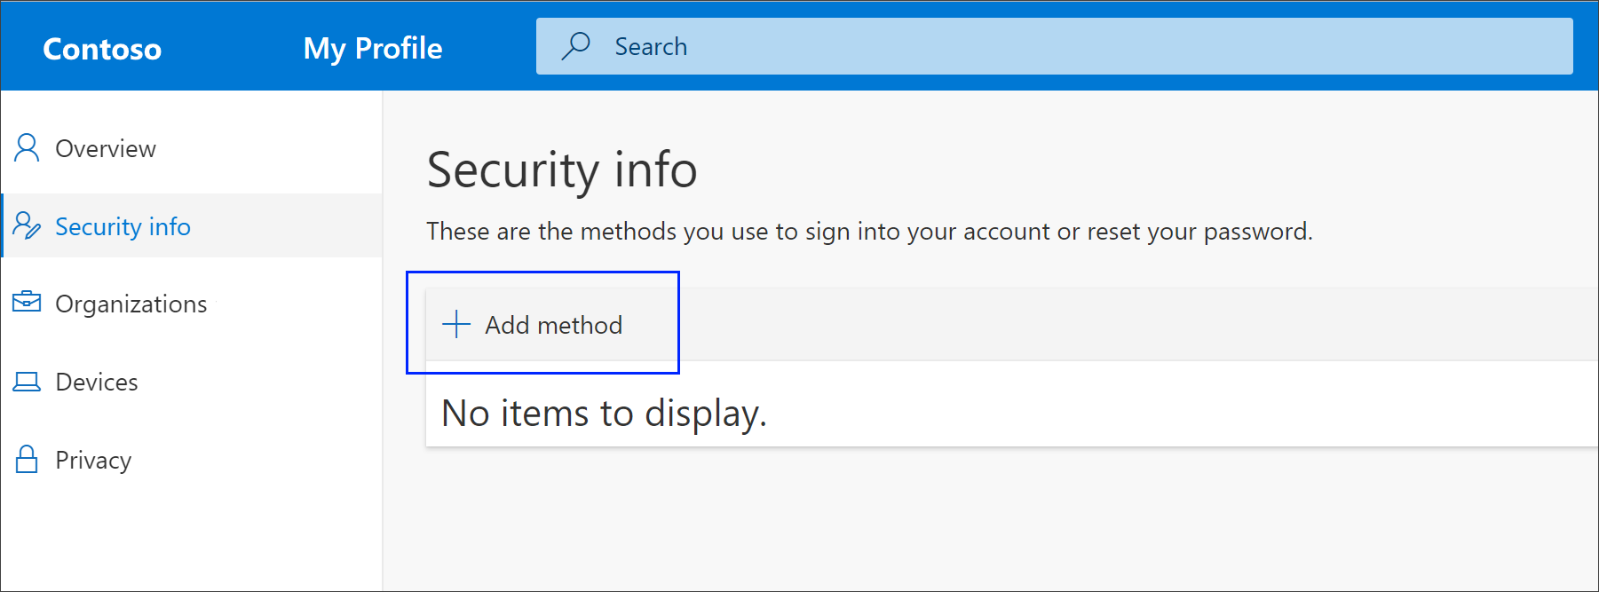
- On the Add a method page, select Authenticator app from the list, and then select Add.
- On the Start by getting the app page, select Download now to download and install the Microsoft Authenticator app on your mobile device, and then select Next. For more information about how to download and install the app, see Download and install the Microsoft Authenticator app.
  - If you want to use an authenticator app other than the Microsoft Authenticator app, select I want to use a different authenticator app.
  - If your organization lets you choose a different method besides the authenticator app, you can select I want to set up a different method.
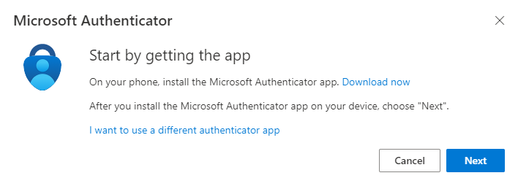
- Remain on the Set up your account page while you set up the Microsoft Authenticator app on your mobile device.
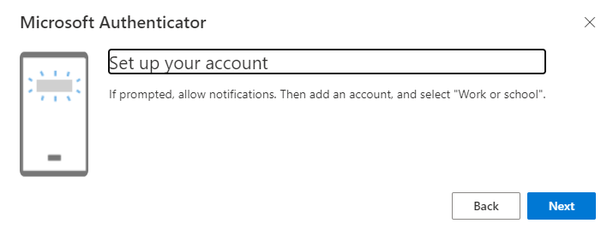
- Open the Microsoft Authenticator app, select to allow notifications (if prompted), select Add account from the Customize and control icon on the upper-right, and then select Work or school account.
Note: The first time you set up the Microsoft Authenticator app, you might receive a prompt asking whether to allow the app to access your camera (iOS) or to allow the app to take pictures and record video (Android). You must select Allow so the authenticator app can access your camera to take a picture of the QR code in the next step. If you don't allow the camera, you can still set up the authenticator app, but you'll need to add the code information manually. For information about how to add the code manually, see section “See Manually add an account to the app”.
- Return to the Set up your account page on your computer, and then select Next. The Scan the QR code page appears.
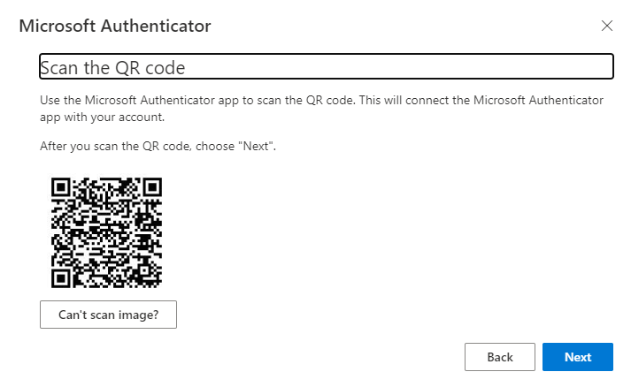
- Scan the provided code with the Microsoft Authenticator app QR code reader, which appeared on your mobile device after you created your work or school account in Step 6.
- If the QR code reader can't read the code, you can select Can't scan the QR code and manually enter the code and URL into the Microsoft Authenticator app. For more information about manually adding a code, see Manually add an account to the app.
- Select Next on the Scan the QR code page on your computer. A notification is sent to the Microsoft Authenticator app on your mobile device which will ask you to enter in a 2-digit code, this is to test your account. Tap on the notification on your phone and enter in the 2-digit code that is displayed on your screen. Note: this is how the app will behavior for all future log ins.
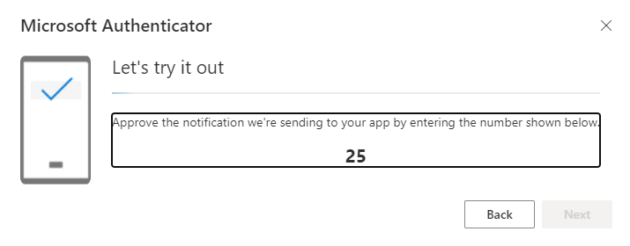
- Approve the notification in the Microsoft Authenticator app, and then select Next. Your security info is updated to use the Microsoft Authenticator app by default to verify your identity when using two-step verification or password reset.
