How to setup an Authorized Payer

Charter Oak’s CASHNet® payment portal allows students to assign a login for a third-party benefactor to submit payments on their behalf. Users have the option to allow third party payers to view electronic bills, notifications and receive Payment Plan e-mail notifications. Third party authorized users will only have access to make payment and view payment history and balances on the student account. The granting of a third-party logon does not allow access to financial aid information, grades, or other online student information.

Step 1: Log into the ACORN student portal: (https://acorn.charteroak.edu/ics)

Step 2: Select the “Tuition and Payments” tab from the navigation bar at the top.

Step 3: Click the “My Account Balance” link to enter the secure payment portal.

Step 4: Click your name on the top left corner, scroll down and select “Send a payer invitation.”

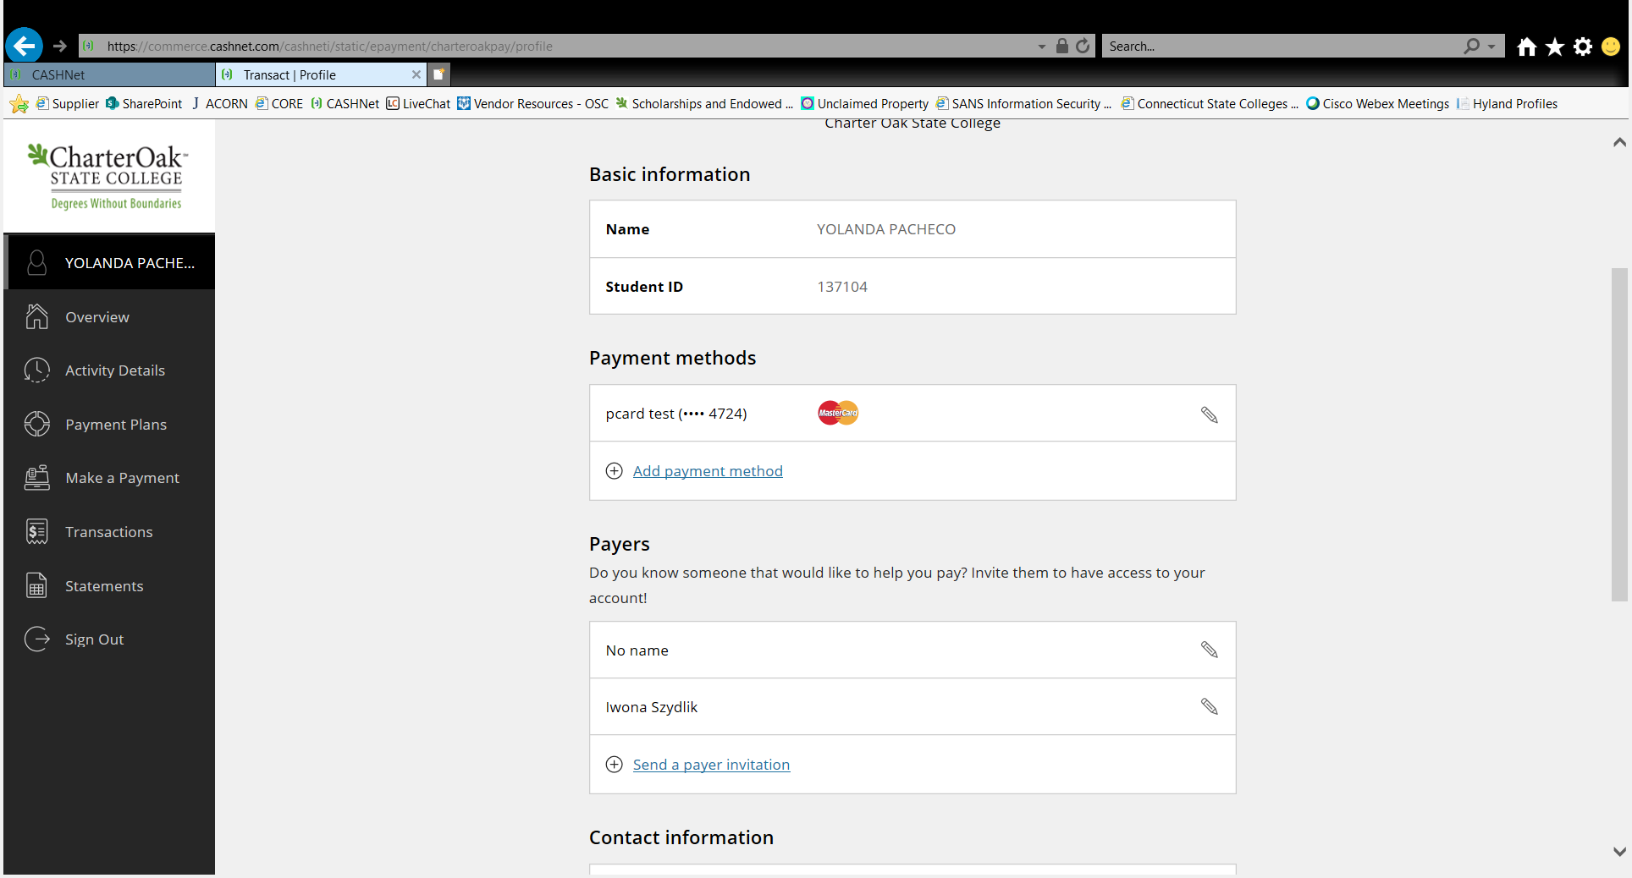
Student Name

Step 5: Fill out the payer information, select if you allow payer access to statements, then click “Send Invitation.” The system will send an e-mail to the authorized payer’s valid e-mail address granting account access.

Authorized Payers:

Click the link provided in the email granting access to the student’s account and login with the credentials provided.

You will be prompted to create a new password and be provided with the option to be notified about the student’s payment plans and/or statements.

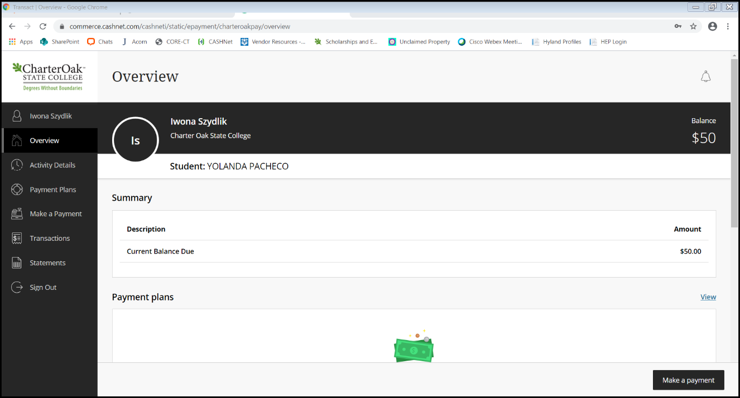
Click continue to enter the secure payment portal to remit payment and/or view statements.

